

National Textile University

**Department of Computer Science**

Subject: Operating System

Submitted to: Sir Nasir Mahmood

Submitted by: Maha

Reg. number: 23-NTU-CS-1170

Lab no.: lab1

Semester:5th

**Connecting with VS Code:**

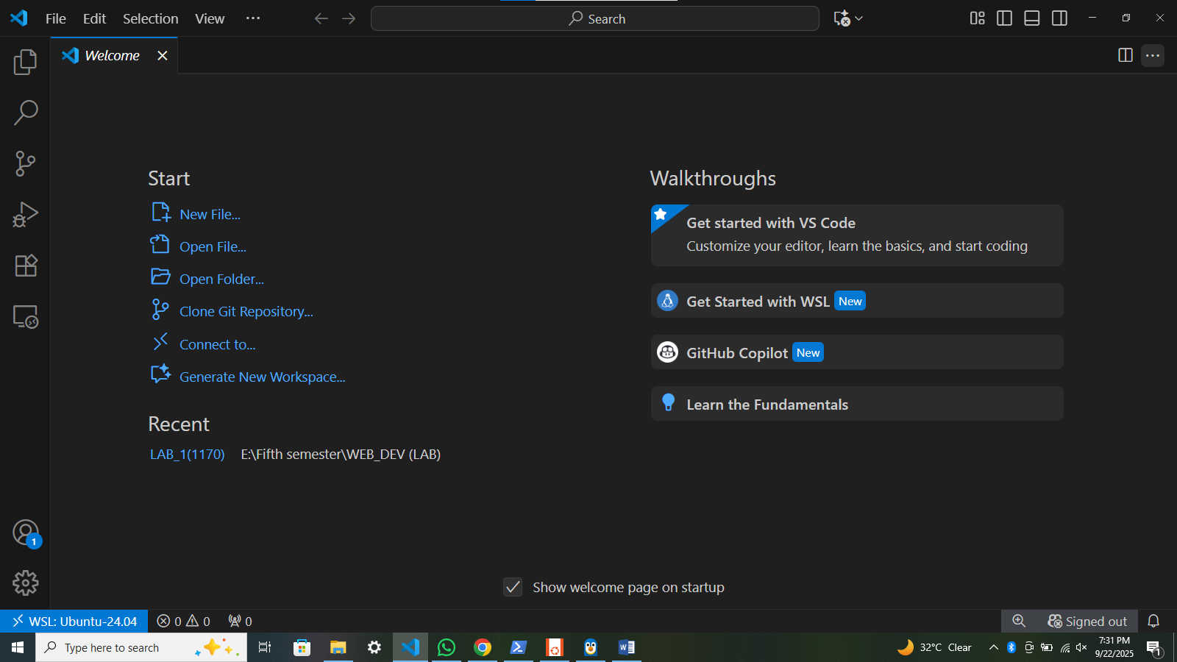

**Commands:**

1. **sudo apt update && sudo apt upgrade -y**

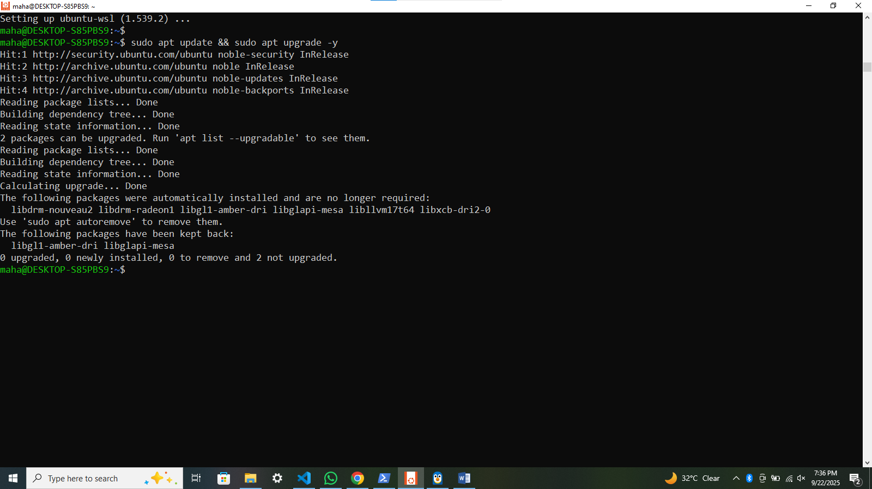

1. **sudo apt install build-essential -y**

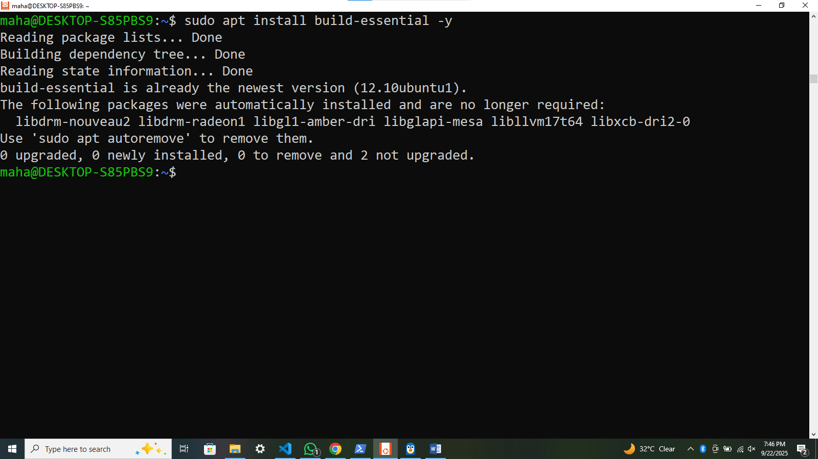

**Wsl -l -v:**

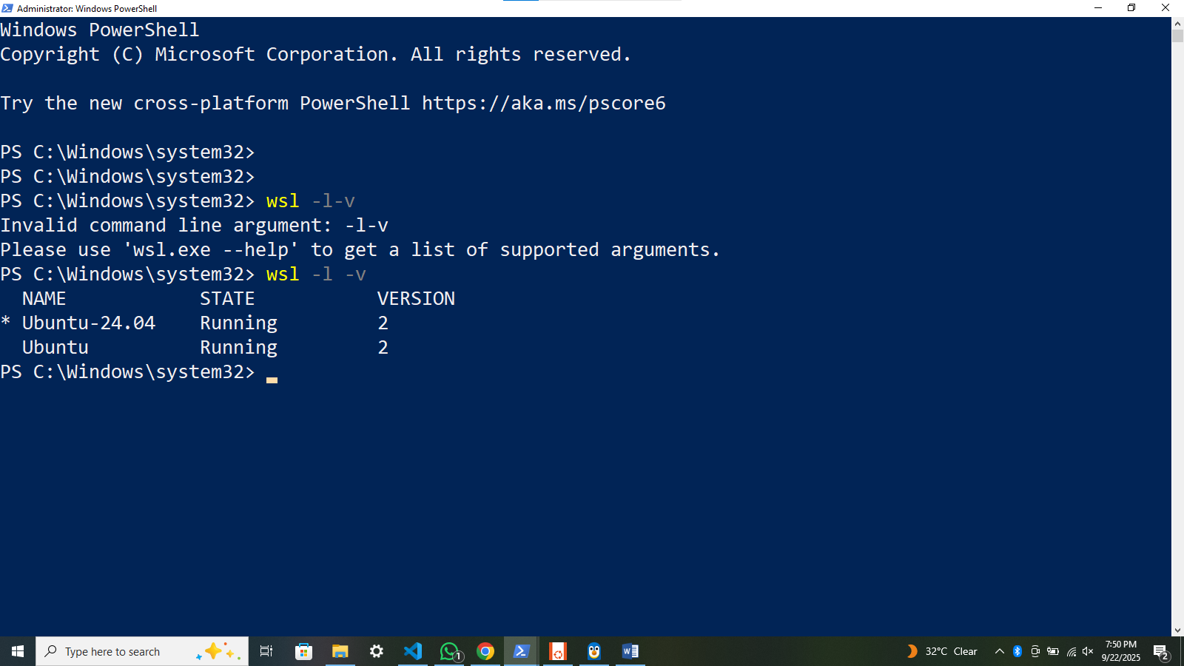

**Gcc –v:**

